

FACULTY OF TECHNOLOGY AND ENGINEERING
DEVANG PATEL INSTITUTE OF ADVANCE TECHNOLOGY AND RESEARCH
DEPARTMENT OF INFORMATION TECHNOLOGY

A.Y. 2026-27 [SEMESTER 3]

LAB MANUAL

CEUE203: Object Oriented Programming


Practical 9

Threads, races, and synchronization
Problem Statement:
1. Counter race: compare unsynchronized and synchronized increments across multiple threads.
2. Seat booking race: coordinate concurrent customers so only available seats are sold.
3. Parallel sum: split an array across workers and combine partial totals safely.

Solution:

CounterRace.java
import java.util.concurrent.CountDownLatch;
public class CounterRace {
private static final class Counter {
private int value;
void incrementWithoutLock() { value++; }
synchronized void incrementWithLock() { value++; }
int value() { return value; }
}
public static void main(String[] args) throws InterruptedException {
int workers = 8;
int increments = 500_000;
Counter unsafeCounter = new Counter();
runWorkers(unsafeCounter, workers, increments, false);
System.out.println("Unsynchronized count: " + unsafeCounter.value());
System.out.println("Expected count: " + (workers * increments));
Counter safeCounter = new Counter();
runWorkers(safeCounter, workers, increments, true);
System.out.println("Synchronized count: " + safeCounter.value());
}
private static void runWorkers(Counter counter, int workers, int increments, boolean safe)
throws InterruptedException {
CountDownLatch start = new CountDownLatch(1);
Thread[] threads = new Thread[workers];
for (int i = 0; i < workers; i++) {
threads[i] = new Thread(() -> {
try {
start.await();
} catch (InterruptedException exception) {
Thread.currentThread().interrupt();
return;
}
for (int j = 0; j < increments; j++) {
if (safe) counter.incrementWithLock();
else counter.incrementWithoutLock();
}
}, "counter-" + i);
threads[i].start();
}
start.countDown();
for (Thread thread : threads) thread.join();
}
}

ParallelSum.java
import java.util.concurrent.atomic.LongAdder;
public class ParallelSum {
public static void main(String[] args) throws InterruptedException {
long[] numbers = new long[100_000];
for (int i = 0; i < numbers.length; i++) numbers[i] = i + 1L;
LongAdder total = new LongAdder();
int workers = 4;
Thread[] threads = new Thread[workers];
for (int worker = 0; worker < workers; worker++) {
int start = worker * numbers.length / workers;
int end = (worker + 1) * numbers.length / workers;
threads[worker] = new Thread(() -> {
long partial = 0;
for (int i = start; i < end; i++) partial += numbers[i];
total.add(partial);
});
threads[worker].start();
}
for (Thread thread : threads) thread.join();
long expected = (long) numbers.length * (numbers.length + 1) / 2;
System.out.println("Parallel sum: " + total.sum());
System.out.println("Expected: " + expected);
}
}

SeatBookingRace.java
import java.util.concurrent.atomic.AtomicInteger;
import java.util.concurrent.CountDownLatch;
public class SeatBookingRace {
private static final class BookingOffice {
private int seatsLeft = 5;
private int booked;
boolean bookWithoutSynchronization(CountDownLatch checked, CountDownLatch release)
throws InterruptedException {
if (seatsLeft == 0) return false;
checked.countDown();
release.await();
seatsLeft--;
booked++;
return true;
}
synchronized boolean book() {
if (seatsLeft == 0) return false;
seatsLeft--;
booked++;
return true;
}
synchronized int booked() { return booked; }
}
public static void main(String[] args) throws InterruptedException {
int customersCount = 10;
BookingOffice unsafeOffice = new BookingOffice();
AtomicInteger unsafeBookings = new AtomicInteger();
CountDownLatch checked = new CountDownLatch(customersCount);
CountDownLatch release = new CountDownLatch(1);
Thread[] customers = new Thread[customersCount];
for (int i = 0; i < customers.length; i++) {
customers[i] = new Thread(() -> {
try {
if (unsafeOffice.bookWithoutSynchronization(checked, release)) {
unsafeBookings.incrementAndGet();
}
} catch (InterruptedException exception) {
Thread.currentThread().interrupt();
}
}, "unsafe-customer-" + i);
customers[i].start();
}
checked.await();
release.countDown();
for (Thread customer : customers) customer.join();
System.out.println("Unsynchronized bookings: " + unsafeBookings.get());
BookingOffice safeOffice = new BookingOffice();
AtomicInteger safeBookings = new AtomicInteger();
for (int i = 0; i < customersCount; i++) {
customers[i] = new Thread(() -> {
if (safeOffice.book()) safeBookings.incrementAndGet();
}, "safe-customer-" + i);
customers[i].start();
}
for (Thread customer : customers) customer.join();
System.out.println("Synchronized bookings: " + safeBookings.get());
System.out.println("Seats booked: " + safeOffice.booked());
}
}

MiniBank Project Work:

MiniBank progress ? Practical 9
Completed: Account deposit, withdraw, and balance access are synchronized. AccountWorker supplies the Runnable task that performs repeated deposits from named worker threads.
Single project location: Java Programs\Minibank

Progressive source excerpts:

Minibank/src/main/java/minibank/model/Account.java ? thread-safe deposit
public synchronized void deposit(long amount) throws InvalidAmountException {
if (amount <= 0) throw new InvalidAmountException("Deposit must be positive.");
balance = Math.addExact(balance, amount);
}

Minibank/src/main/java/minibank/model/Account.java ? thread-safe withdrawal
public synchronized boolean withdraw(long amount)
throws InsufficientFundsException, InvalidAmountException {
if (amount <= 0) throw new InvalidAmountException("Withdrawal must be positive.");
if (!canWithdraw(amount)) {
throw new InsufficientFundsException(Math.max(0, amount - balance));
}
balance = Math.subtractExact(balance, amount);
return true;
}

Minibank/src/main/java/minibank/service/AccountWorker.java
package minibank.service;
import minibank.exception.InvalidAmountException;
import minibank.model.Account;
public final class AccountWorker implements Runnable {
private final Account account;
private final int times;
private final long amount;
public AccountWorker(Account account, int times, long amount) {
if (times < 0) throw new IllegalArgumentException("Times cannot be negative.");
this.account = account;
this.times = times;
this.amount = amount;
}
@Override
public void run() {
for (int i = 0; i < times; i++) {
try {
account.deposit(amount);
System.out.println(Thread.currentThread().getName() + " deposited " + amount);
} catch (InvalidAmountException exception) {
System.err.println("Deposit failed: " + exception.getMessage());
return;
}
}
}
}

Output Screenshot:
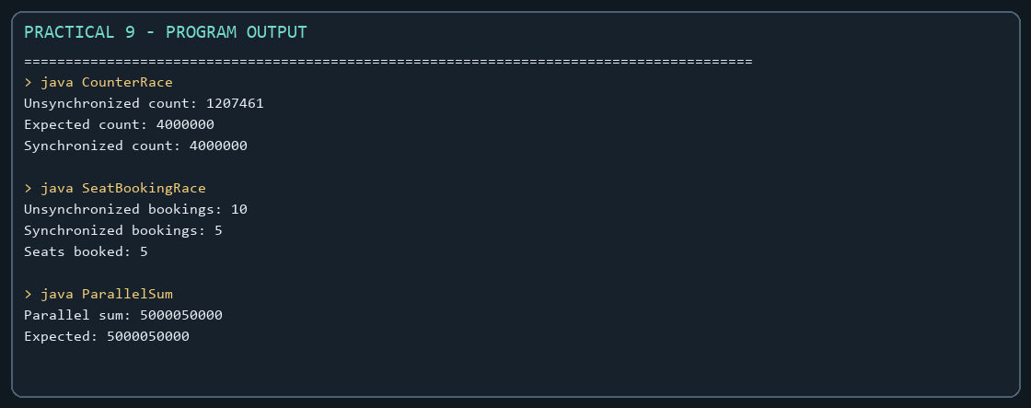
Captured from the compiled practical programs.

